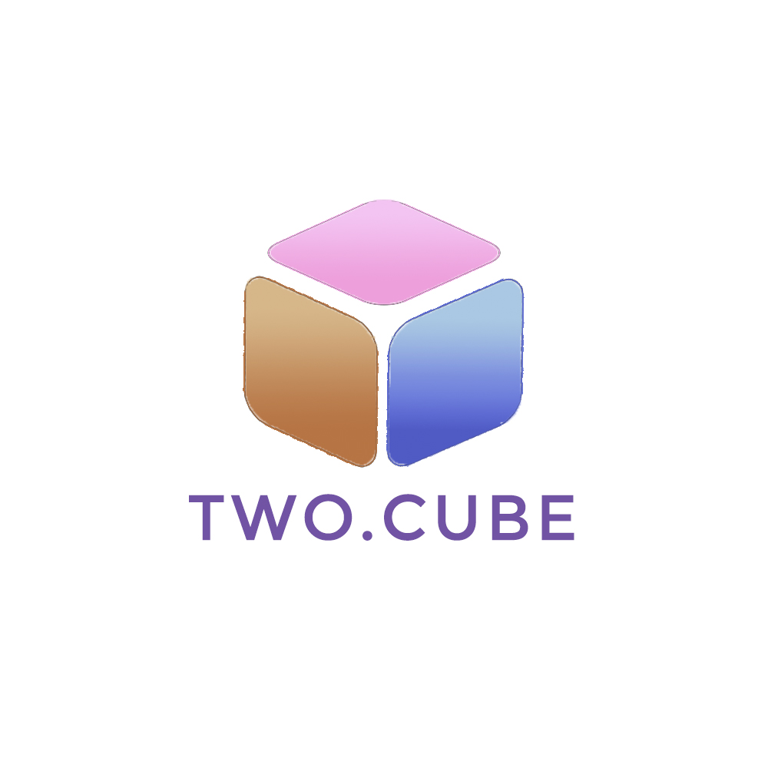

**IS480 Project Proposal**

**RoboStudio**

**Two Cube**

**V4**

**22nd October 2017**

**Team Members:**

* **Deborah Sim** (deborah.sim.2015@sis.smu.edu.sg) – Project Manager & Scrum Master
* **Sebastian Choo Kok Wee** (kwchoo.2015@sis.smu.edu.sg) – Business Analyst Lead & Quality Assurance
* **Abdul Haqqim** (abdulhaqqim.2015@sis.smu.edu.sg) – Developer Lead & Business Analyst Deputy
* **Jack New** (jack.new.2015@sis.smu.edu.sg) – Developer Lead & Robotics Hardware Deputy
* **Vera Low** (vera.low.2015@sis.smu.edu.sg) – Robotics Hardware Lead & Developer Deputy
* **Ahmad** (ahmadsm.2015@sis.smu.edu.sg) – Front-End & UI/UX designer

**Faculty Supervisor:**

* **Tan Hwee Xian** (hxtan@smu.edu.sg) - SMU-TCS iCity Lab Senior Research Scientist

**Sponsor and/or Clients (if any):**

* **Ben Li** (ben.li.2016@mi.smu.edu.sg) - Product Owner

# Project Overview

## Project Description:

Remote RoboLab is an online web platform that aims to promote python learning with robotics without the need of a physical robot on the users’ end. Remote RoboLab aims to make learning a fun and interactive experience for the users through the gamification approach, where there is a main goal and users control the movement of the robots to accomplish that goal. Remote RoboLabs does this by providing a code editor for the users which guides them on what code to enter. Upon entering the correct code into the code editor, users will be able to see the movements of robots via a live camera. The users will be charged by half hour blocks for the usage of these remote robots.

Remote RoboLabs’ mission is to provide an easy, fun and affordable Python learning assistance for everyone.

Our project aims to target *Game Players*.

Game Players are users who will be playing the games provided on the web platform to learn/improve Python.

Our project will also offer two types of game forms: *Single-player* and *Multiple-player*.

For multiplayers, the focus of the project would be multiplayer games where several Game Players can play games such as robot race or robot soccer. Furthermore, the concept of multiplayers has a social aspect whereby there is interaction between the users while playing the provided games.

(*Puzzle track – Players navigate their robots through a puzzle track*)

(*Robot race - Multiplayers remotely control their own robot with the goal of reaching the finishing lines before their opponents*)

## Motivation:

There are several motivations for our group to take up this project. They are as follows: -

**The uprising of smart cities and usage of robotics in many industries**

There is an increasing trend in the usage of robotics in many industries. (“59% of manufacturing companies are already currently using some sort of robotics technology”). Leveraging on this market potential will allow us to gain a competitive edge in the education and gaming hotspot industries in the market.

**Robotics as a learning tool to introduce programming**

New students who intend to learn programming may find it hard and mundane at the start. However, by having the opportunity to control a robot and seeing what goes wrong with it, students can better visualize what is wrong with their code by looking at how the robots execute them. Additionally, the students will also learn the need to be precise with their instructions so that the robots will run the code how they intended it to be.

**Expensive Robotic kits and connectivity hassle**

There are some platforms out there that teaches python robotics programming as well as how to get up and connect the robots. However, a single robot kit is very pricey and not everyone has the financial capabilities to purchase one. Additionally, not many will choose to take the risk to purchase one just for interests or learning purposes. Hence our platform is the solution for these people where they can simply pay a small and affordable price to use our platform which has almost the same benefits as owning a robot kit themselves but at a much lower cost. Additionally, the setting up and connecting the robot requires the user’s time, effort as well as a space of their own for the robot. Remote RoboLab takes away all these hassles from the user and allows user to be to focus on just learning to code.

**Suitable for everyone with a range of abilities**

There is no background programming experience needed to engage with the robots that are provided by RoboStudio. The complexity of the code is solely up to the individual. Because of this, younger students will not be deterred from learning programming. In addition, learning how to code or program using Robots is always a fun and engaging thing to do. Hence, this will help students in being more interested and helped them develop.

## Stakeholders:

|  |  |
| --- | --- |
| Sponsor | Ben Li is the one who initiated the project. He is the product owner and founder of RoboStudio. |
| User | We will be targeting both new and experienced users who are keen in learning and improving Python Robotics Programming. We are also targeting users who are looking to earn some money by providing innovative robotics games for other users. |
| Advisors/  Practitioners/  Mentors | There may be other parties such as schools or institutions and robot kit providers that maybe interested in working with the project. |

## Deliverables:

## Web application with an online platform to allows users to choose and play games, either alone or with other users, provided by RoboStudios or Game Providers.

## Scope:

## Our scope is focused on providing an interactive platform for users interested in learning or improving python robotics programming. The core functions are to provide users with a platform to learn, from the many different games provided. Secondary functions are useful add-ons that allows other users to view the live games of users playing. Also, it allows administrators to better manage their robot kit inventories. Some of our good-to-have functions promotes a supportive robotics community by having player donations and well as a chat bot to assist new users on how to get started and answer any enquiries of existing users.

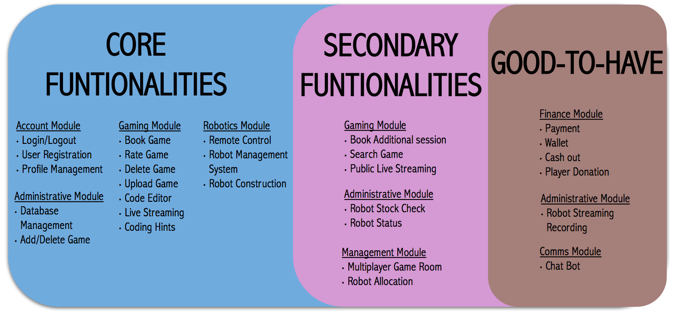

# Project Plan

## Project milestone:

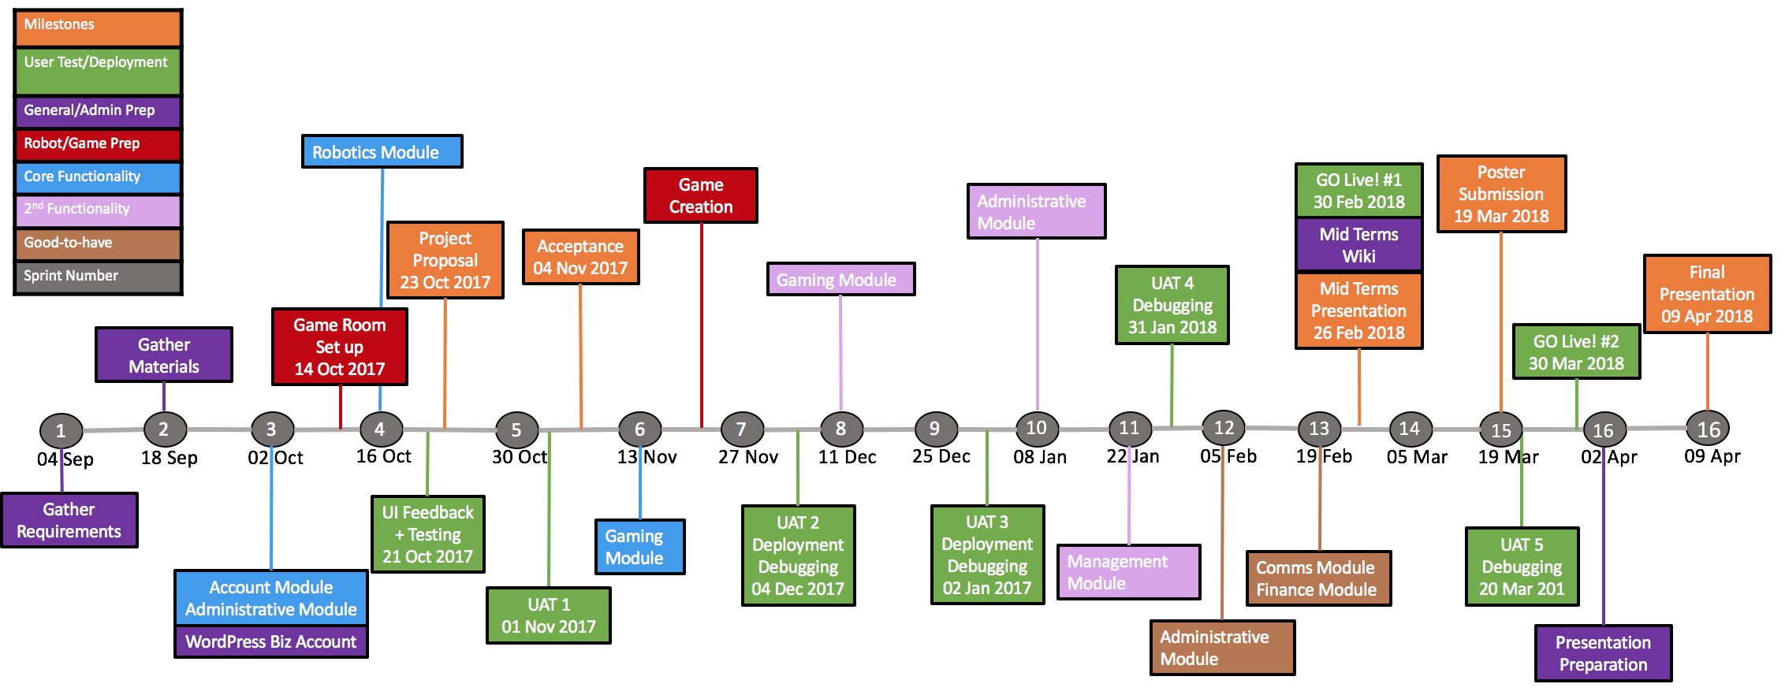

## Risks:

|  |  |  |  |
| --- | --- | --- | --- |
| Risk Type | Risks | Intensity | Mitigations |
| Technical | Team is unfamiliar with working with robotics hardware. | Medium | Team members will do up the necessary research (many available resources online) and consult our supervisors & sponsor. |
| Technical | Failure to send instructions to the robot. | High | Team members will equip ourselves with robotic knowledge and actively seek others’ help and consult our supervisors to do our best to overcome the problem. |
| Hardware | Malfunction of the robot/robotics parts which requires replacement.*Eg. Overheating of robot motherboard, breaking of robot frame* | Medium | Careful usage of robot when testing as well as to stock up on critical robot parts that are essential for the robot to function so that there will be no time wasted in replacement of the robot parts. |
| Client Management | There may be many changes in the business and platform requirements as our project proceeds. | High | The team will meet with our sponsor weekly to get regular updates on requirements. |
| Project Management | Delaying of Project due to inaccurate time estimation on functionalities and unfamiliarity with robotics hardware. | Medium | Constantly review project schedule and make any adjustments along the way to the upcoming sprints if necessary. |

## Resources and References:

We will be researching on how to send codes remotely from our web platform to a physical Raspberry PI robot remotely. Also, we will increase our knowledge of the Python Robotics Programming by going to the websites listed below. The following also details the technologies used for the entire course of this project.

Websites: Dexter Industries. WordPress

Libraries: GoPiGo

Programming Language(s): Python, HTML, CSS

Software and Tool(s): GitHub, Trello

Database: MySQL